Nama : Taufik Hidayat

NIM : 301200032

Kelas : IF Pagi

**Tugas Pemrograman Berorientasi Objek: Inheritance dan Polymorphism pada Java dan PHP**

1. **Java**
2. **Source Code**

Motor.java

|  |
| --- |
| package inheritance;  public class Motor {  private String merk, tipe, warna;  private int tahun;    public Motor(String merk, String tipe, String warna, int tahun) {  this.merk = merk;  this.tipe = tipe;  this.warna = warna;  this.tahun = tahun;  }    public String getMerk() {  return this.merk;  }    public String getTipe() {  return this.tipe;  }    public String getWarna() {  return this.warna;  }    public int getTahun() {  return this.tahun;  }    public void jalankan() {  System.out.println("Nyalakan motor...");  }  } |

MotorMatic.java

|  |
| --- |
| package inheritance;  public class MotorMatic extends Motor {  public MotorMatic(String merk, String tipe, String warna, int tahun) {  super(merk, tipe, warna, tahun);  }  @Override  public void jalankan() {  System.out.println("Nyalakan motor lalu gas");  }  } |

MotorKopling.java

|  |
| --- |
| package inheritance;  public class MotorKopling extends Motor {  public MotorKopling(String merk, String tipe, String warna, int tahun) {  super(merk, tipe, warna, tahun);  }  @Override  public void jalankan() {  System.out.println("Nyalakan motor, tarik kopling, naik gigi, lalu perlahan lepas kopling dan gas");  }  } |

MotorBebek.java

|  |
| --- |
| package inheritance;  public class MotorBebek extends Motor {  public MotorBebek(String merk, String tipe, String warna, int tahun) {  super(merk, tipe, warna, tahun);  }  @Override  public void jalankan() {  System.out.println("Nyalakan motor, naik gigi, lalu gas");  }  } |

Main.java

|  |
| --- |
| package inheritance;  import inheritance.MotorBebek;  import inheritance.MotorKopling;  public class Main {  public static void main(String[] args) {  MotorMatic matic = new MotorMatic("Yamaha", "Nmax", "Abu-abu", 2021);  MotorKopling kopling = new MotorKopling("Suzuki", "Satria F150", "Biru", 2020);  MotorBebek bebek = new MotorBebek("Honda", "Supra X", "Merah", 2019);    System.out.println(  "Motor Matic\n"  + "Merk : " + matic.getMerk() + "\n"  + "Tipe : " + matic.getTipe() + "\n"  + "Warna: " + matic.getWarna() + "\n"  + "Tahun: " + matic.getTahun()  );  matic.jalankan();    System.out.println(  "\nMotor Kopling\n"  + "Merk : " + kopling.getMerk() + "\n"  + "Tipe : " + kopling.getTipe() + "\n"  + "Warna: " + kopling.getWarna() + "\n"  + "Tahun: " + kopling.getTahun()  );  kopling.jalankan();    System.out.println(  "\nMotor Bebek\n"  + "Merk : " + bebek.getMerk() + "\n"  + "Tipe : " + bebek.getTipe() + "\n"  + "Warna: " + bebek.getWarna() + "\n"  + "Tahun: " + bebek.getTahun()  );  bebek.jalankan();  }  } |

1. 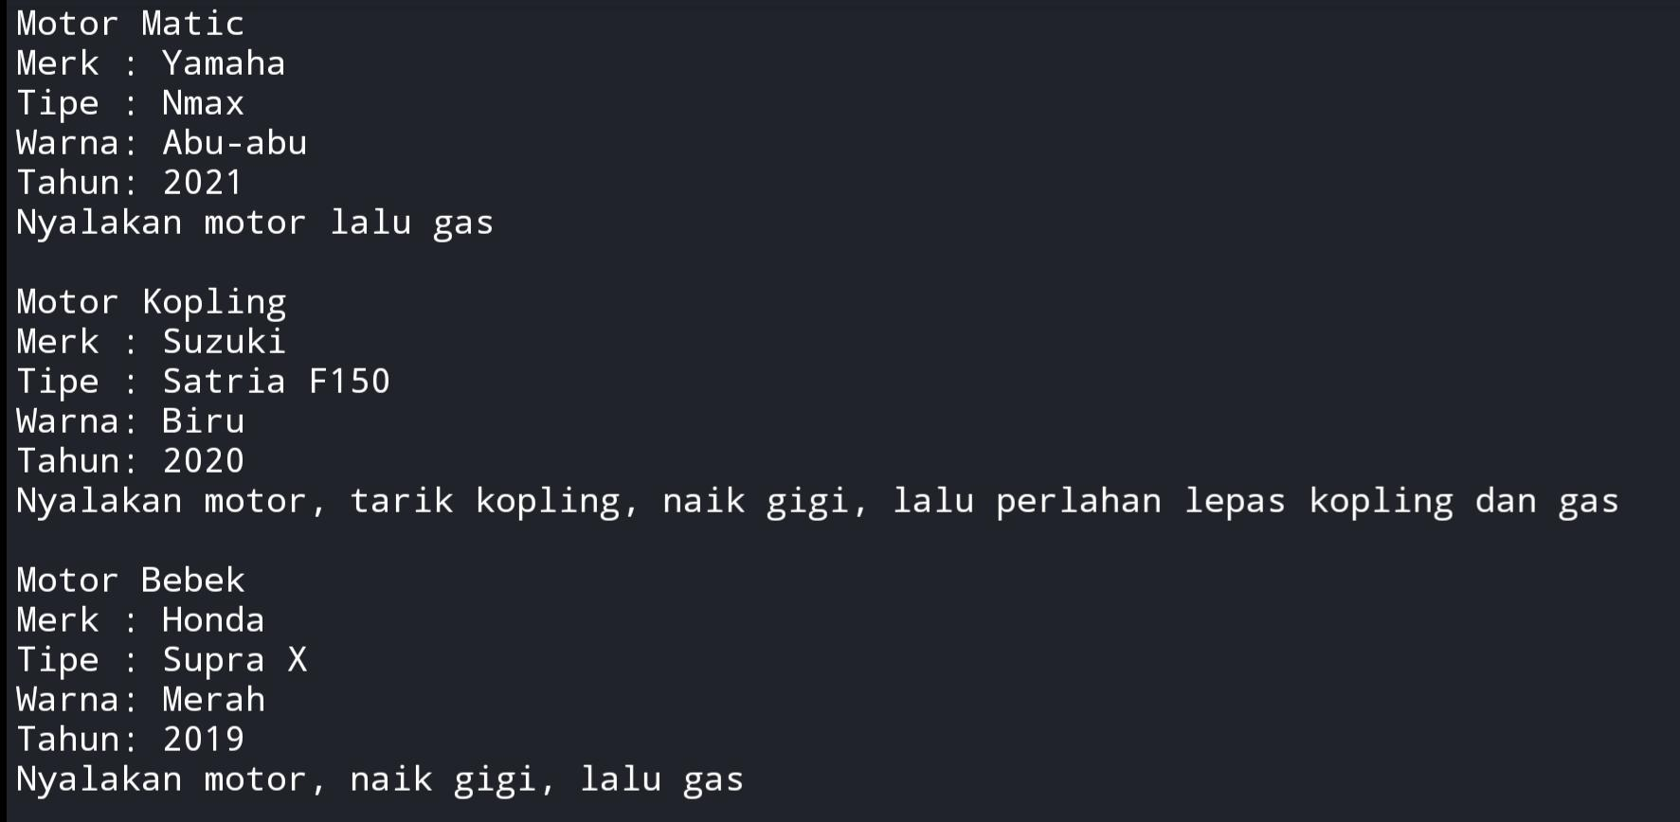**Output**
2. **PHP**
3. **Source Code**

index.php

|  |
| --- |
| <?php  class Motor {  private $merk, $tipe, $warna, $tahun, $gambar;  public function __construct($merk, $tipe, $warna, $tahun, $gambar) {  $this->merk = $merk;  $this->tipe = $tipe;  $this->warna = $warna;  $this->tahun = $tahun;  $this->gambar = $gambar;  }  public function getMerk() {  return $this->merk;  }  public function getTipe() {  return $this->tipe;  }  public function getWarna() {  return $this->warna;  }  public function getTahun() {  return $this->tahun;  }  public function getGambar() {  return $this->gambar;  }  public function jalankan() {  return "Nyalakan motor...";  }  }  class MotorMatic extends Motor {  public function __construct($merk, $tipe, $warna, $tahun, $gambar) {  parent::__construct($merk, $tipe, $warna, $tahun, $gambar);  }  public function getMerk() {  return parent::getMerk();  }  public function getTipe() {  return parent::getTipe();  }  public function getWarna() {  return parent::getWarna();  }  public function getTahun() {  return parent::getTahun();  }  public function getGambar() {  return parent::getGambar();  }  public function jalankan() {  return "Nyalakan motor, lalu gas...";  }  }  class MotorKopling extends Motor {  public function __construct($merk, $tipe, $warna, $tahun, $gambar) {  parent::__construct($merk, $tipe, $warna, $tahun, $gambar);  }  public function getMerk() {  return parent::getMerk();  }  public function getTipe() {  return parent::getTipe();  }  public function getWarna() {  return parent::getWarna();  }  public function getTahun() {  return parent::getTahun();  }  public function getGambar() {  return parent::getGambar();  }  public function jalankan() {  return "Nyalakan motor, tarik kopling, naik gigi, lalu perlahan lepas kopling dan gas...";  }  }  class MotorBebek extends Motor {  public function __construct($merk, $tipe, $warna, $tahun, $gambar) {  parent::__construct($merk, $tipe, $warna, $tahun, $gambar);  }  public function getMerk() {  return parent::getMerk();  }  public function getTipe() {  return parent::getTipe();  }  public function getWarna() {  return parent::getWarna();  }  public function getTahun() {  return parent::getTahun();  }  public function getGambar() {  return parent::getGambar();  }  public function jalankan() {  return "Nyalakan motor, naik gigi, lalu gas...";  }  }  $matic = new MotorMatic("Yamaha", "Nmax", "Abu-abu", 2021, "nmax.jpg");  $kopling = new MotorKopling("Suzuki", "Satria F150", "Putih", 2020, "satria.jpg");  $bebek = new MotorBebek("Honda", "Supra X", "Merah", 2019, "supra.jpg");  ?>  <!DOCTYPE html>  <html>  <head>  <meta name="viewport" content="width=device-width, initial-scale=1.0">  <title>Inheritance & Polymorphism PHP</title>  <link rel="preload" as="image" href="asset/images/nmax.jpg">  <link rel="preload" as="image" href="asset/images/satria.jpg">  <link rel="preload" as="image" href="asset/images/supra.jpg">  <!-- Development -->  <!-- <link rel="stylesheet" href="node_modules/bootstrap/dist/css/bootstrap.min.css"> -->  <!-- Production -->  <link rel="stylesheet" href="dist/css/bootstrap.min.css">  <link rel="stylesheet" href="dist/css/style.css">  </head>  <body>  <div class="container">  <div class="row mx-1 my-3">  <div class="col-12 col-md-10 mx-auto">  <div class="card">  <div class="card-header fw-bold">  Inheritance dan Polymorphism pada PHP  </div>  <div class="card-body">  <div class="row mx-auto">  <!-- Navbar -->  <div class="col-12">  <ul class="nav nav-tabs nav-fill" id="myTab" role="tablist">  <li class="nav-item" role="presentation">  <button class="nav-link active" id="matic" data-bs-toggle="tab" type="button" role="tab" aria-selected="true">Motor Matic</button>  </li>  <li class="nav-item" role="presentation">  <button class="nav-link" id="kopling" data-bs-toggle="tab" type="button" role="tab" aria-selected="false">Motor Kopling</button>  </li>  <li class="nav-item" role="presentation">  <button class="nav-link" id="bebek" data-bs-toggle="tab" type="button" role="tab" aria-selected="false">Motor Bebek</button>  </li>  </ul>  </div>  <!-- Content -->  <div class="col-12 mt-2 content">  </div>  </div>  </div>  <div class="card-footer text-muted text-center fw-light">  <a href="https://github.com/tfkhdyt" target="_blank" class="text-reset text-decoration-none">Taufik Hidayat | 301200032 | Informatika</a>  </div>  </div>  </div>  </div>  </div>  <script src="dist/js/bootstrap.bundle.min.js"></script>  <script>  let merk, tipe, warna, tahun, gambar;  const nav = document.getElementsByClassName('nav')[0];  const content = document.getElementsByClassName('content')[0];    const render = (merk, tipe, warna, tahun, gambar, jalankan) => {  content.innerHTML = `  <div class="row">  <div class="col-md-5 mt-md-2">  <img src="asset/images/${gambar}" class="img-fluid">  </div>  <div class="col-md-7 mt-md-2">  <div class="row">  <div class="col-3 text-nowrap">  Merk  </div>  <div class="col-9">  : <b>${merk}</b>  </div>  </div>  <div class="row">  <div class="col-3 text-nowrap">  Tipe  </div>  <div class="col-9">  : <b>${tipe}</b>  </div>  </div>  <div class="row">  <div class="col-3 text-nowrap">  Warna  </div>  <div class="col-9">  : <b>${warna}</b>  </div>  </div>  <div class="row">  <div class="col-3 text-nowrap">  Tahun  </div>  <div class="col-9">  : <b>${tahun}</b>  </div>  </div>  <div class="row">  <div class="col-12 fst-italic text-wrap">  ${jalankan}  </div>  </div>  </div>  </div>  `;  };    render(  '<?= $matic->getMerk() ?>',  '<?= $matic->getTipe() ?>',  '<?= $matic->getWarna() ?>',  '<?= $matic->getTahun() ?>',  '<?= $matic->getGambar() ?>',  '<?= $matic->jalankan() ?>'  );    nav.addEventListener('click', (e) => {  // if(e.target.classList.contains('active')) return;  content.classList.add('fade');  const jenis = e.target.id;  switch(jenis) {  case 'matic':  merk = '<?= $matic->getMerk() ?>';  tipe = '<?= $matic->getTipe() ?>';  warna = '<?= $matic->getWarna() ?>';  tahun = '<?= $matic->getTahun() ?>';  gambar = '<?= $matic->getGambar() ?>';  jalankan = '<?= $matic->jalankan() ?>';  break;  case 'kopling':  merk = '<?= $kopling->getMerk() ?>';  tipe = '<?= $kopling->getTipe() ?>';  warna = '<?= $kopling->getWarna() ?>';  tahun = '<?= $kopling->getTahun() ?>';  gambar = '<?= $kopling->getGambar() ?>';  jalankan = '<?= $kopling->jalankan() ?>';  break;  case 'bebek':  merk = '<?= $bebek->getMerk() ?>';  tipe = '<?= $bebek->getTipe() ?>';  warna = '<?= $bebek->getWarna() ?>';  tahun = '<?= $bebek->getTahun() ?>';  gambar = '<?= $bebek->getGambar() ?>';  jalankan = '<?= $bebek->jalankan() ?>';  break;  }  console.log(jenis, merk);  setTimeout(() => {  render(merk, tipe, warna, tahun, gambar, jalankan);  content.classList.remove('fade');  }, 500);  });  </script>  </body>  </html> |

1. 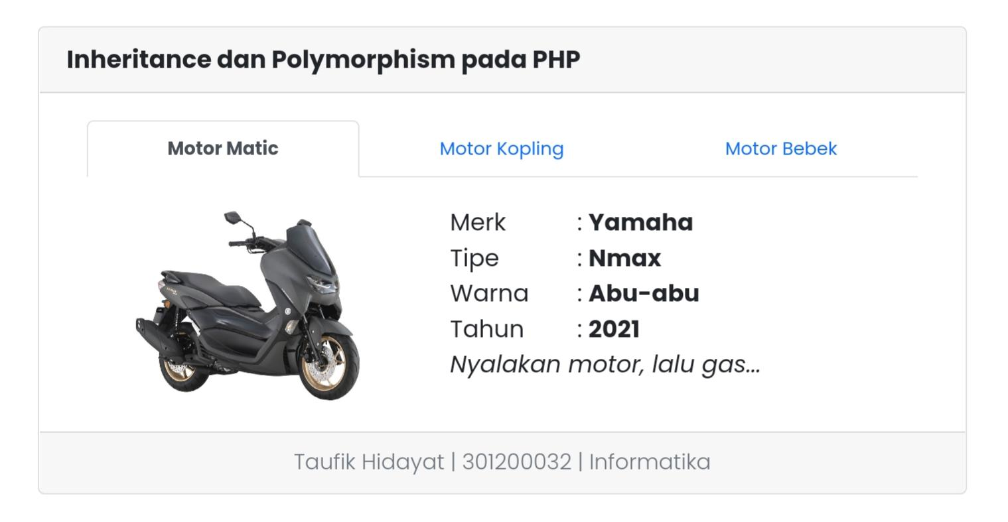**Output**

